Project Design Phase-II

Data Flow Diagram & User Stories

Date | 17 February 2026
Team ID | LTVIP2026TMIDS66150
Project Name | Prosperity Prognosticator: Machine Learning for Startup Success Prediction
Maximum Marks | 4 Marks

Data Flow Diagrams:

The Data Flow Diagram represents how data flows through the Prosperity Prognosticator system. The system accepts startup-related inputs from users, processes the data using a machine learning model, and produces startup success predictions.

Main Components
- User (Entrepreneur / Investor)
- Startup Success Prediction System
- Machine Learning Model
- Database
Data Flow Explanation
- User enters startup details (funding, market, business features).
- System validates and preprocesses the input data.
- Data is sent to the machine learning model.
- The model analyzes historical patterns and predicts startup success.
- Prediction results are stored in the database.
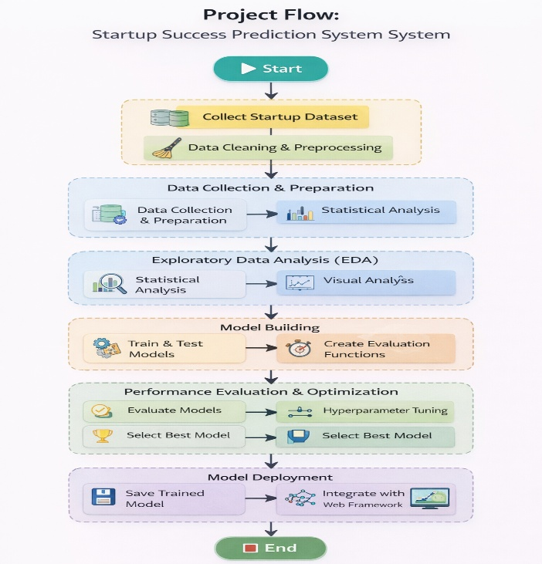
- The system displays success probability and insights to the user.

Example :

User Type | Functional Requirement (Epic) | User Story No | User Story / Task | Acceptance Criteria | Priority | Release
Customer (Web User) | Registration | USN-1 | As a user, I can register by providing email and password | User account is created successfully | High | Sprint-1
Customer (Web User) | Login | USN-2 | As a user, I can log in using valid credentials | User accesses dashboard | High | Sprint-1
Customer (Web User) | Data Input | USN-3 | As a user, I can enter startup details for prediction | Data is accepted without errors | High | Sprint-1
Customer (Web User) | Prediction | USN-4 | As a user, I can view startup success prediction results | Prediction result is displayed | High | Sprint-1
Customer (Web User) | Analysis | USN-5 | As a user, I can view probability score and insights | Insights are clearly shown | Medium | Sprint-2
Investor | Comparison | USN-6 | As an investor, I can compare multiple startups | Comparison results are visible | Medium | Sprint-2
Administrator | Data Management | USN-7 | As an admin, I can manage startup datasets | Dataset updates are saved | High | Sprint-1
Administrator | Model Management | USN-8 | As an admin, I can update or retrain ML models | Model updates successfully | Medium | Sprint-2

